Standard Five
Students will discover the importance and elements used in developing a PROMOTION MIX to market sports businesses.

Promotion
A marketing function needed to :

Role of Promotion

Promotional Goals

Promotional Mix

Personal Selling
The form of promotion that determines client needs and wants and responds though planned, personalized communication that influences purchase decisions and enhances future business opportunities.

Advertising

Sales Promotion

Public Relations

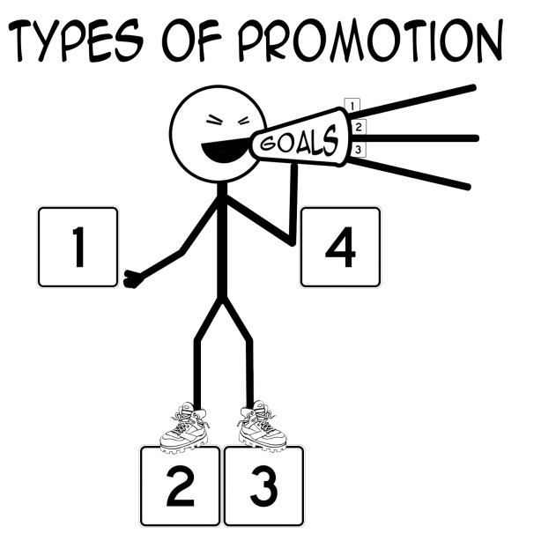

Media Types

Advertising Schedule
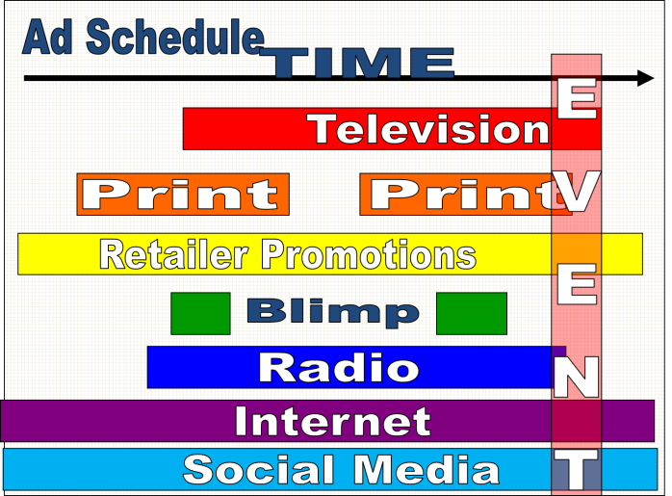

Promotions are

Promotions typically

Promotions typically

Advertising schedule organizes

Promotion Budgeting
- Fund the Primary Promotion

- Fund the secondary promotions

