Marketing is a ___________ of ___________, promoting, and distributing _________ to _________ customers’ ________ and __________.
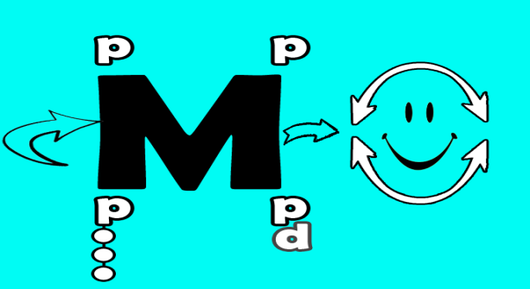

Sports
Sports are a source of ___________________ ______________________________ engaged in for pleasure

Can be
Can be

Sports Marketing
Sports Marketing uses _______________________________ to meet the ___________________ of a sports property.

What is Marketed?

DURABLE GOODS

NONDURABLE GOODS

SERVICES

IDEAS

PEOPLE

PLACES

ORGANIZATIONS

Identification of Marketing: Good, Service, or Idea?

The Elements of Marketing
P =
P =
P =
P =

Sports Marketing Mix:
__________________ Strategies
__________________ Strategies
__________________ Strategies
__________________ Strategies
__________________ Strategies

Seven Core Functions of Marketing
1.
2.
3.
4.
5.
6.
7.

Producers
Individuals or Companies which _____________ ___________________________________
They provide the “_________________.”
They are willing to exchange the product or service for ___________________________.

Sports Producers
Sports Producers May Provide:
___________ for Participation
Events for Entertainment __________________
Sporting __________________ and Equipment
Licensed ____________________________
Collectables and _______________________
_________________________ Training
Sports Information
Event Coverage and Distribution

Consumers
Individuals or Companies which have _________ _________________ and have something to exchange.
They create a “___________________.”
They have something to exchange for a product or service and are ________________________.

Sports Consumers
Consumers __________________________ money for a “wanted” good or service.
Sports Consumers exchange in different ways:
Spectators as Consumers
Benefit by ___________________ game
Exchange for _____________________
& ____________________________

Participants as Consumers
Benefit by ___________ or ____________
Exchange for _______________________

Exchanges
Everyday transactions between _____________& _________________
Typically trading ___________ for a product or service

Benefits of Marketing
Add _______________________ to goods and services

Makes buying _________________________________

Maintains reasonable __________________________

Provides a ___________________ of goods and services

Increases ____________________

