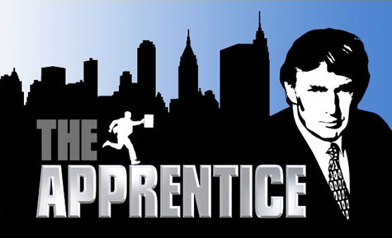

**Managing Conflict**

**Assignment** – **Watch an episode of The Apprentice and write a one page paper describing the following:**

* From the show describe a situation in which conflict occurred
* Describe how the conflict was “Functional” or “Dysfunctional”
* Of the five Conflict strategies discussed in class, which one was used.
* Describe how the team leader managed the conflict